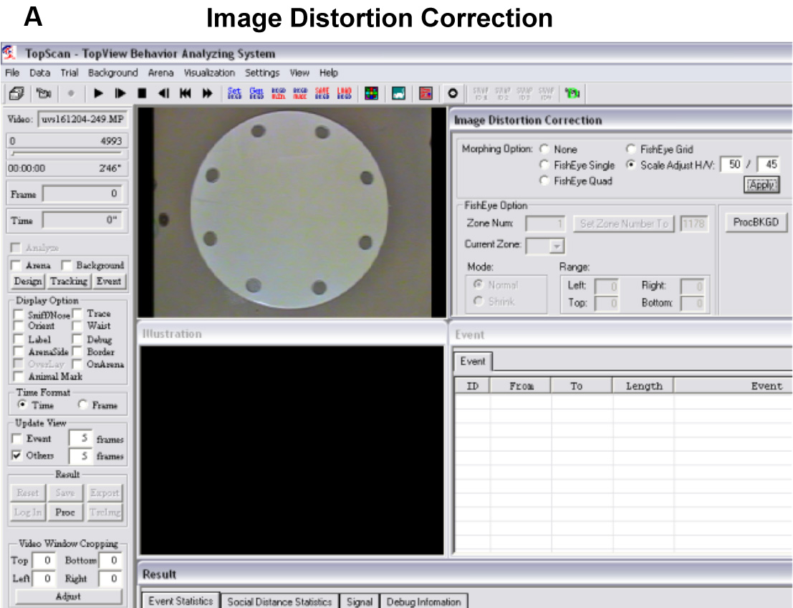
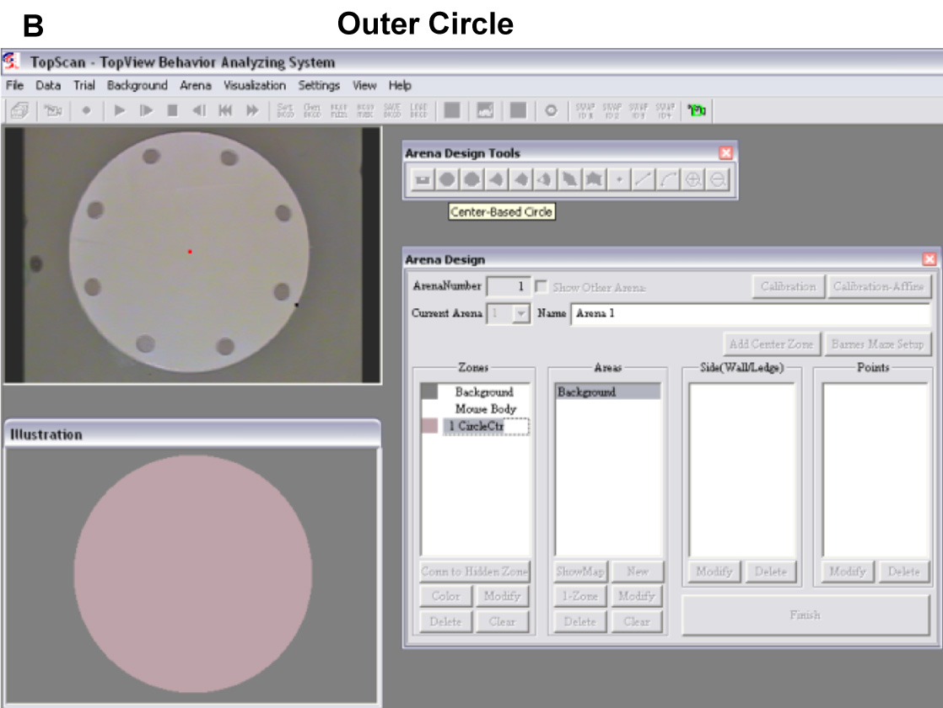
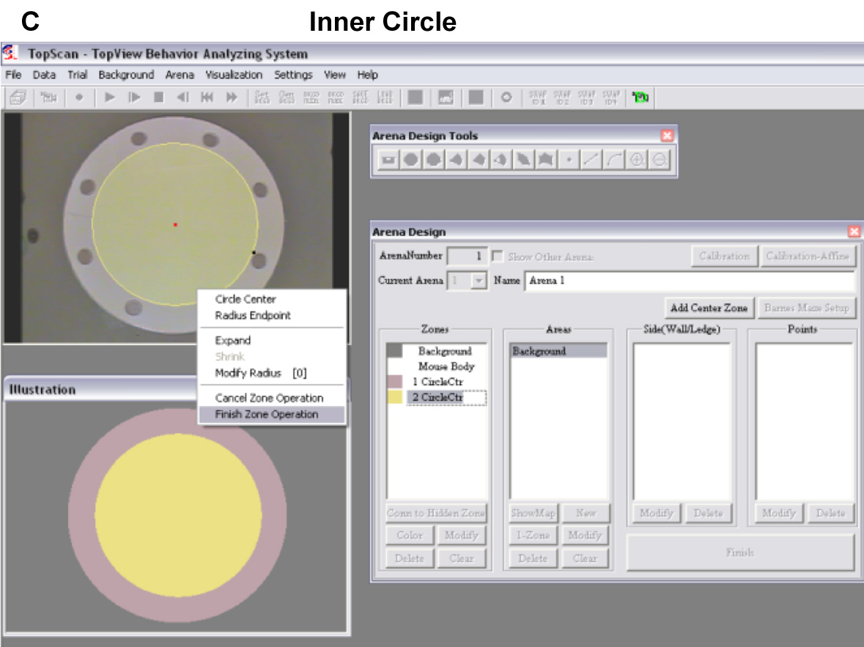
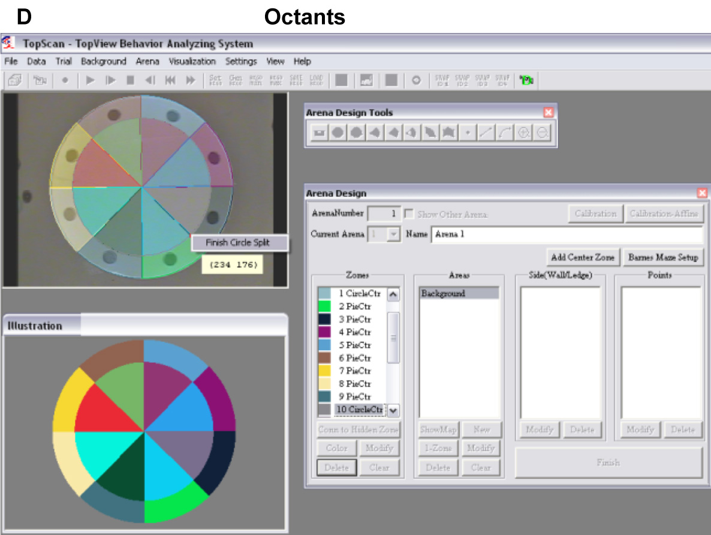
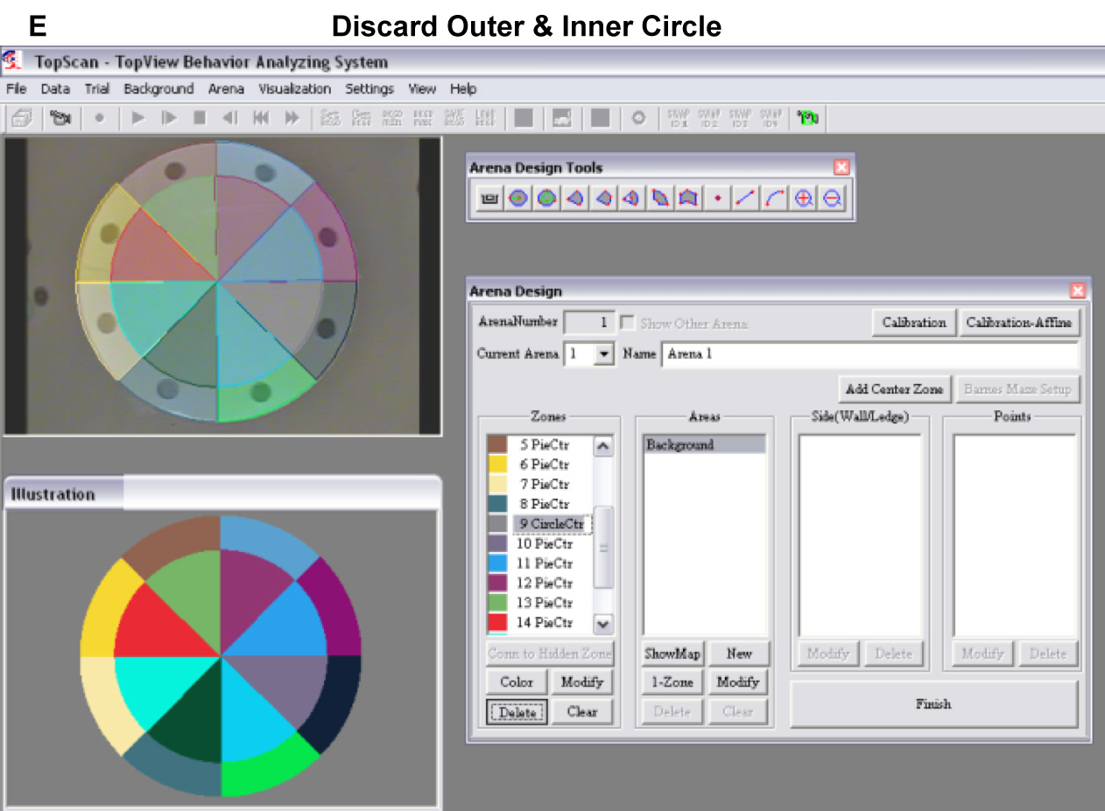
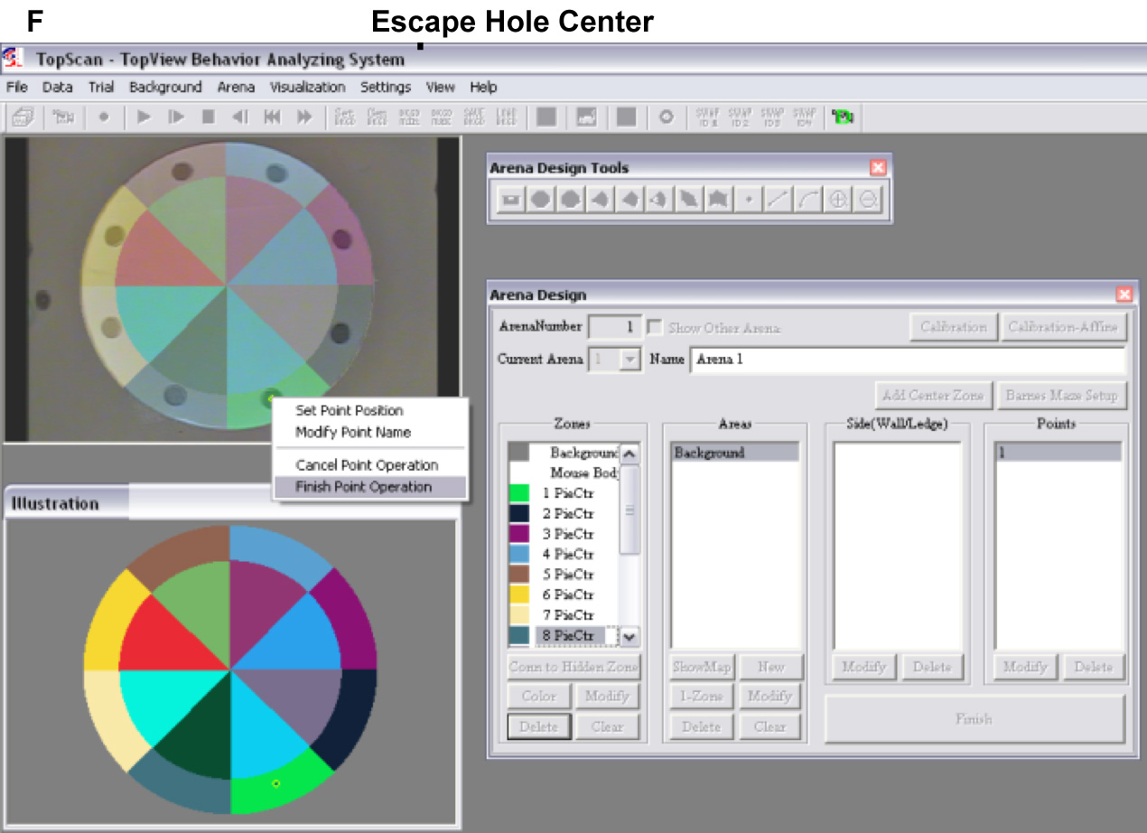
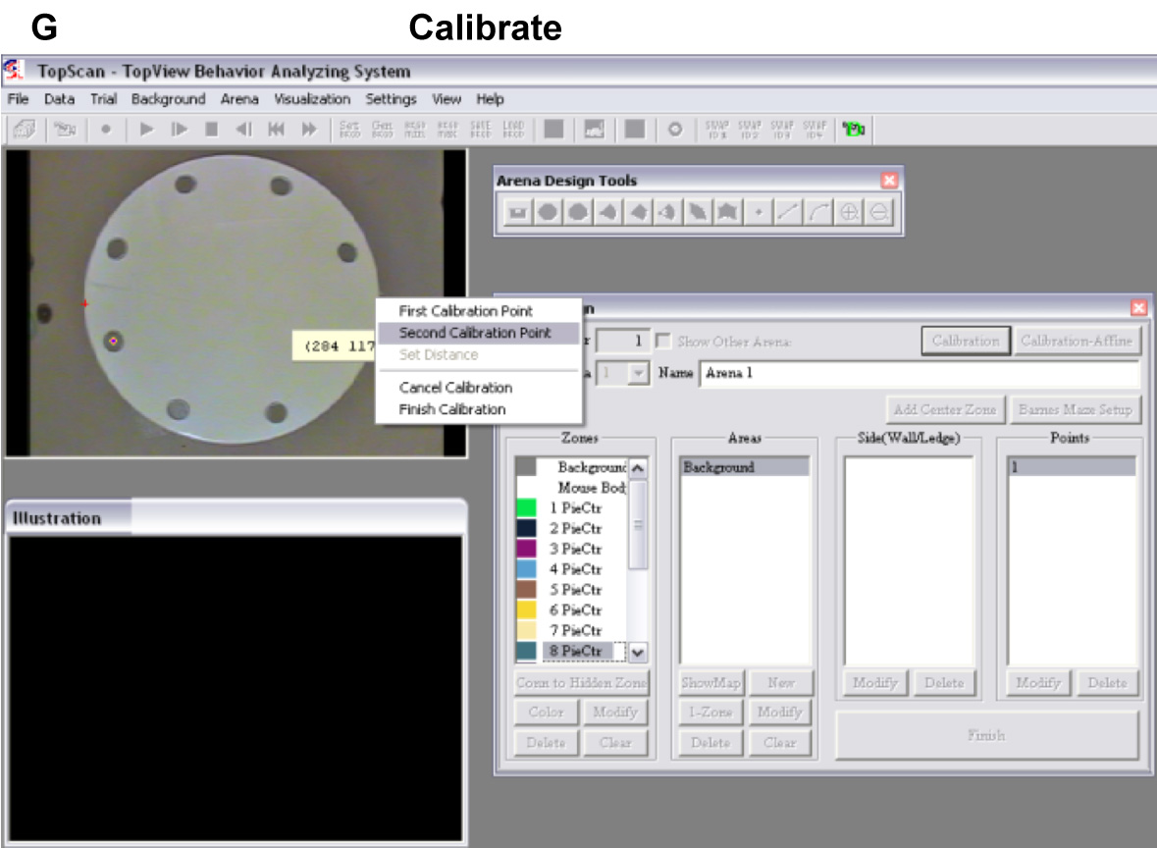
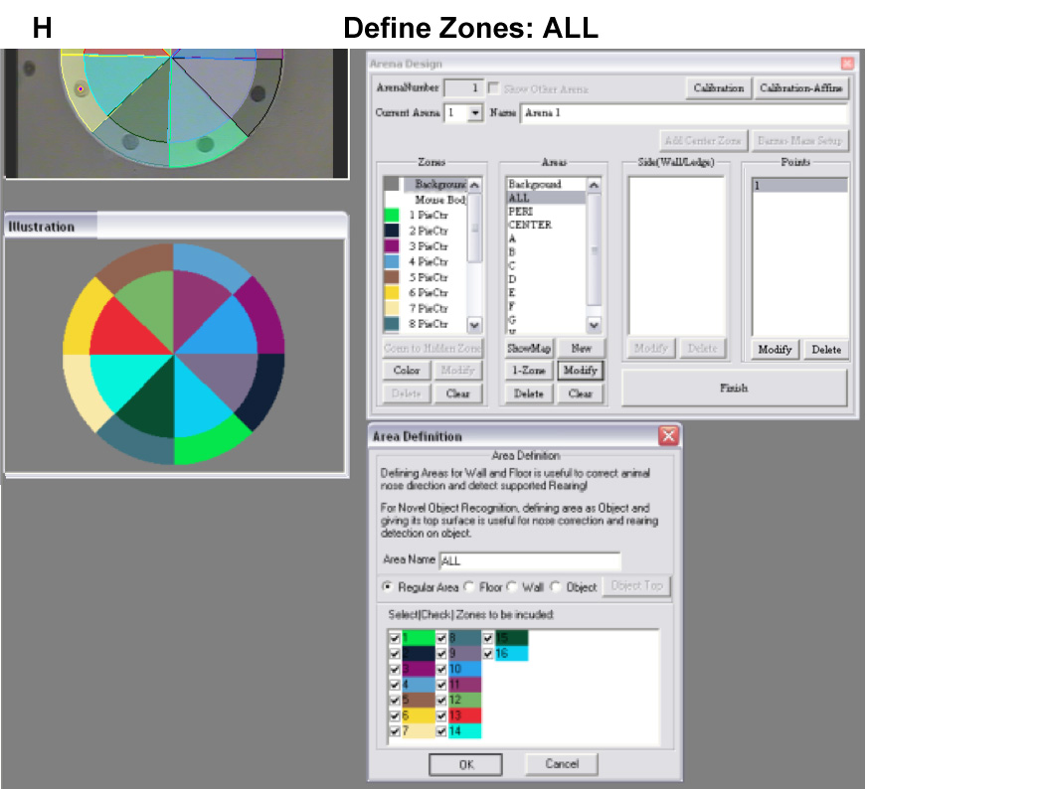
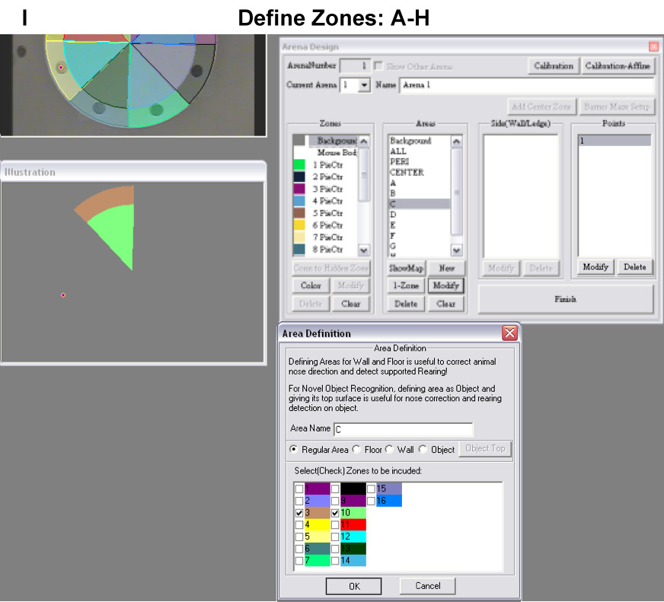
Figure S1. Arena setup. A. Screenshot of image distortion correction using the ‘eye’ icon. B-F. Screenshots of creating arena zones. B. Outer circle. C. Inner circle. D. Octants. E. Discarding outer and inner circles, creating escape hole center using the ‘point’ tool. G. Calibrating the maze area. H-I. Screenshots of defining arena zones. H. ‘ALL’ zone. I. Defining escape holes A-H octant zones.

